Service excellence
- Service is hard to separate from human error. The more intangible a service is, the more opportunity to deviate from customer needs.
- Effective recovery can transform an angry customer into a customer who advocates your firm. But this should not be reactive or informal.

Shouldice Hospital case study
- Relies upon word-of-mouth advertising
- Semi-private 2-bed rooms, pairing patients of similar jobs, backgrounds, or interests. Patients are given time to acquaint themselves on the first evening. Then they have dinner, recreation and snacks in the evening, with nurses emphasising the importance of attending as patients can talk to others who have just had the operation.
- Patients encouraged to walk to the post-op room immediately afterwards, for the psychological benefit of proving to themselves they can do it. Patients are also encouraged to exercise the day after, and explore the premises and make new friends.
- The “Shouldice Technique”; through repetition (performing 750 hernia operations a year vs 50 of the typical surgeon, Shouldice surgeons develop an understanding of “pace and touch”. Surgeons are also encouraged to immediately consult other surgeons if they encounter something unusual, via a group effort.
- Where possible, former patients suffering recurrences are assigned to the doctor who performed the first operation, so he can learn from his mistakes.
- Only thee housekeeping staff for the entire facility; saves costs and also intended to encourage patients to be up socialising and encouraging each other as opposed to staying in bed.

Offering
- Shouldice’s value proposition is holistic care, cheap and good quality
- Peace of mind staycation with a social experience
- Successful offering as they are able to offer a wage premium, with an employee wait list, despite low prices for customers
  - They also have a backlog of patients
  - Other hospitals and surgeons trying to copy them

Funding mechanism
- How to leverage value over cost – maximise perceived quality and value provided, against the cost of providing the service
- Achieved through framing operations such as carefully screening surgeons, avoiding general anaesthetic, implementing communal dining.
  - The clinic is a focused factory, with highly productive surgeons, standardised approaches, with repetition and homogeneity breeding competence
- Also achieved by getting customers to perform work, with patients active in their own recovery and performing tasks like application forms, training new patients, feeding themselves.

Employee management system

Employee selection
- Surgeons selected when exhibiting characteristics including being a team player, willing to stick to procedures (no prima donnas) and will take ownership of mistakes (recurrence)
  - Peer group pressure through surgeons observing each other – peculiarities immediately shared with other surgeons
  - Recurrences sent to same surgeon
- Nurses selected based on their experience and expertise, ability to be empathetic when talking to patients, and their ability to be motivating and firm with both patients and surgeons.

Employee Incentives
- There are number of incentives which motivates employees to achieve excellence, and allows Shouldice to remain selective in its recruitment processes
  - Work-life balance – 7:30 till 4pm
  - Good salary and bonus
  - Opportunity to specialise
  - Association with clinic’s reputation
  - Certainty of tenure

Customer management system
- Due to its extensive waiting list, Shouldice can choose its patients, and therefore is able to reduce customer reduce variation, which in turn allows service excellence.
- They set several criteria for admission into the hospital:
  - Patient cannot be overweight, as this would increase the risk of complications and failure. Similarly, patients must have good overall health
  - Patient’s hernia must be external, allows more focused specialisation
  - Patient’s hernia cannot be a recurrence unless it is from a Shouldice surgery. Reduces the risk of complications and other surgeon’s failures being passed onto Shouldice.
- Customer anxiety dealt with by mixing post-op and pre-op patients of similar backgrounds in dorms. Clan controls through socialisation incentivise patients to engage in the system, in which ‘cry-babies’ are not supported

Variability
Request variability, effort variability, capability variability, subjective measures of quality, arrival variability. Request (everyone wants same thing), arrival (schedules), effort (nurses and housekeeping staff, self-selection), portable anaesthesia,
Focused factory idea
A set of mutually reinforcing decisions
Mutually reinforcing elements, benefits of specialisation and management of quality in a service environment

Pillars of service excellence (Frei, 2008)
Service excellence achieved by balancing and aligning four pillars: service offering, funding mechanism, employee management system, and customer management system
- Offering must effectively meet the needs and desires of an attractive group of customers. Service designers should focus on the experience customers want to have, rather than just the characteristics of a product they will value. To create a successful service offering, managers need to determine which attributes to target for excellence and which to target for inferior performance, based on their understanding of the relative importance their customer segment places on different attributes (links to marketing).
- Funding mechanism: with tangible products the funding mechanism is simple – the price tag. For services, developing ways to fund excellence is more complicated. In services, pricing is not transaction based but involves bundling, or subscription. Some nonbuyers can even derive value e.g., gaining knowledge from a salesperson but not buying. There are four methods of funding excellence:
  - Charge the customer in a palatable way. For example, in Starbuck’s the appeal is that customers can linger indefinitely in the coffee shop – this is paid for by charging more for the coffee, as opposed to place meters next to its chairs
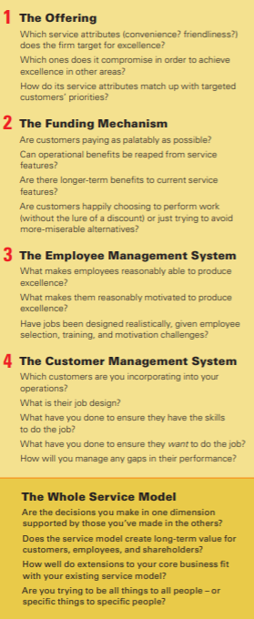
  - Create a win-win between operational savings and value-added services. Example is the immediate-response services provided by Progressive Casualty Insurance. Customers value this, but would not pay extra for it, however the service pays for itself because of the reduced rates of frauds as they arrive to the scene before police. Framing operations.
  - Make customers do the work i.e., self-checkout
  - Principles to achieve this include spending now to save later (Intuit free customer support to inform future product developments) and having customers do the work by offering self-service (because the goal is service excellence you must create a situation in which this is preferable for the customer).
- Employee Management System: service businesses are typically labour intensive which makes workforce quality even more important. Questions to consider: what makes employees able to achieve excellence, what makes them motivated to achieve excellence. If you require employee heroism to keep customers happy, you have bad service by design; employee self-sacrifice is not a sustainable resource.
  - Often expensive to hire employees with above average aptitude and attitude, so firms may have to compromise on one.
- Customer Management System: for many services, customers are actively involved with operational processes and can thus affect the value added to the output. For example, someone dithering at a fast-food restaurant impacts the experience of those waiting in line. Customers are less experienced than employed labour, lower skilled and more heterogeneously skilled. Managers should understand which customers they are focusing on, which behaviours they want, and what techniques will most effectively induce that behaviour.
- Integrating the elements. All four elements of service design must be incorporated, but the interconnection of the four is more important than any one element.

Operational transparency (Buell, 2019)
- Automated teller machines (ATMs) are less expensive and more efficient than human tellers and allow customers to withdraw at any hour. However, when customers use an ATM their overall level of satisfaction goes down; they feel as though less effort has gone into the service because, even though the ATMs carry out complex work, this is not visible to the customer.

Summary of idea
- The less contact a customer has with an operation, the more efficiently it tends to run. But portioning customers from the operation makes them less likely to appreciate the behind-the-scenes work, therefore they will place a lower value on the output. The solution is that managers should experiment with operational transparency. This will increase their willingness to pay, satisfaction and loyalty. It can also increase employee satisfaction. However, there are conditions which must be met for this to be the case.

Behind the curtain
- In an experiment by the author, people who received instantaneous flight-finding service perceived the service to be as valuable as people who waited 25 seconds with a progress bar, and as valuable as people who waited 55 seconds with operational transparency.
  - Remarkable in an era in which customers expect online services to be delivered in fractions of a second.
- When customers have operational transparency, they perceived that more effort went into the delivery of the service. They also believed that the service provider had more expertise and was being more thorough. They appreciated that effort and quality, and they in turn valued the service more

Risk of backfire
- It can reveal details customers do not want to see e.g., trash collection or a violent police altercation. However, this can still sometimes be leveraged; a city called Halifax switched to clear trash bags so that everyone could see what was being thrown away, and recycling increased by 20%
- It can engender anxiety
- It can expose an ineffective process
- It can destroy the magic / show a company’s products are inferior to competitors
Sometimes customers would appreciate effort and therefore value the service more if there is some visibility. Law firms make their effort visible to justify their high fees.

Understanding failure and service recovery lecture notes

Cost of a lost customer
- Using the restaurant example, we have the lost revenue of the meal, presuming the customer does not pay, and the lost revenue of any future meals the customer may have consumed at our restaurant if not for the failure.
- Additionally, the customer will have networks of family, friends and colleagues, and customers are more likely to share negative experiences than positive ones. At its most extreme, this can result in the type of word-of-mouth advertising seen in the United airlines example.
- Together, these components represent the lifetime value of the consumer, which is the maximum amount the firm should be willing to spend on service recovery. Backward induction
  - Errors are inevitable but dissatisfied clients are not
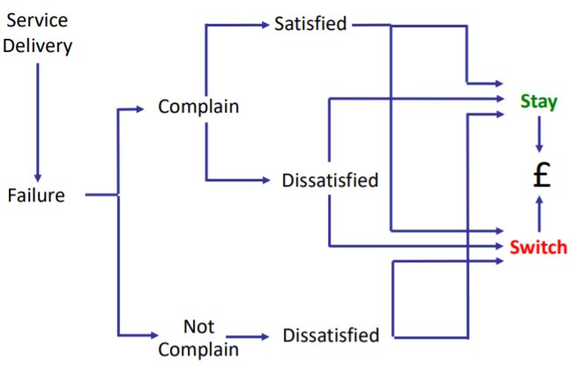
  - A good recovery can turn angry clients into loyal clients and create even more goodwill than if things had gone smoothly.

Complaint value chain
- We can seek to improve recovery from complaints, which represent an increase in probability of moving to the satisfied node form the complain node. This is done by creating perceived justice for the customer using social exchange theory:
  - Distributive justice is the idea that the resource offering should be in proportion to the failure presented to the customer.
  - Procedural justice is the fairness and transparency of the processes by which decisions are made (how easy resolution is).
  - Interactional justice is the degree to which people affected by the decision are treated with dignity and respect (Schermerhorn). Focused on interpersonal treatment.
- We can also encourage feedback and surface problems to reduce the proportion of customers who do not complain, as these customers are more likely to switch and represent a missed, valuable, opportunity to identify failures in our process at no cost.
  - Toyota see problems as a positive because they are a chance to improve.

- Preventing failure prevents us having to follow the complaint value chain in the first place. This can be done through general operational efficiency, and more specifically poka-yokes.
  - Server poka-yokes are those which affect employees
    - Task poka-yokes prevent work being done incorrectly
    - Treatment poka-yokes prevent a lack of courtesy e.g., doors ringing in shops
    - Tangible poka-yokes prevent errors in tangibles e.g., towels signal when cleaned
  - Customer poka-yokes are those created to prevent customers from failing
    - Preparation poka-yokes, which prevent failure to bring necessary materials e.g., text from doctors to remind you when your appointment is
    - Encounter poka-yokes prevent inattention or misunderstanding, e.g., visual signals such as height measurements at fair rides
    - Resolution poka-yokes prevent a failure to signal service failure

